**Project Design Phase-II**

**Data Flow Diagram & User Stories**

|  |  |
| --- | --- |
| Date | 03 October 2022 |
| Team ID | PNT2022TMID19156 |
| Project Name | Project - Smart Lender - Applicant Credibility Prediction for Loan Approval |
| Maximum Marks | 4 Marks |

**Data Flow Diagrams:**

A Data Flow Diagram (DFD) is a traditional visual representation of the information flows within a system. A neat and clear DFD can graphically depict the right amount of the system requirement. It shows how data enters and leaves the system, what changes the information, and where data is stored.

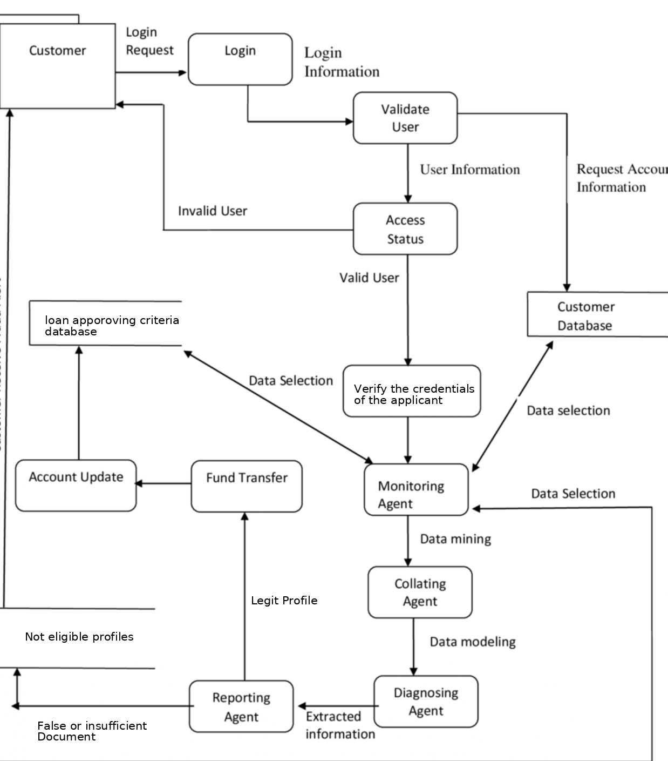

**User Stories**

Use the below template to list all the user stories for the product.

| **User Type** | **Functional Requirement (Epic)** | **User Story Number** | **User Story / Task** | **Acceptance criteria** | **Priority** | **Release** |
| --- | --- | --- | --- | --- | --- | --- |
| Customer (Mobile user) | Registration | USN-1 | As a user, I can register for the application by entering my email, and password, and confirming my password. | I can access my account/dashboard | High | Sprint-1 |
|  |  | USN-2 | As a user, I will receive a confirmation email once I have registered for the application | I can receive a confirmation email & click confirm | High | Sprint-1 |
|  |  | USN-3 | As a user, I can register for the application through Gmail | I can register & access the dashboard with Gmail Login | Low | Sprint-1 |
|  |  | USN-4 | As a user, I can register for the application through Hotmail or Yahoo mail | I can receive a confirmation email & click confirm | Medium | Sprint-1 |
|  | Login | USN-5 | As a user, I can log into the application by entering my email & password | Login successful | High | Sprint-1 |
|  | Dashboard | USN-6 | As a user, I should have access to the dashboard and be able to use anything. | Dashboard Access | Medium | Sprint-1 |
| Customer (Web user) | Registration | USN-7 | As a user, I can sign up for the application by providing my email address, password, and password confirmation. | My account / Dashboard is  Accessible | High | Sprint-1 |
|  |  | USN-8 | As a user, Once I've signed up for the application, I'll get a confirmation email. | I can receive a confirmation email & click confirm | High | Sprint-1 |
|  |  | USN-9 | As a user, I can sign up for the application as a user through Gmail. | I can register & access the dashboard with Gmail Login | Low | Sprint-1 |
|  | Login | USN-10 | As a user, You can log in to the application by entering your email address and password | Able to log in | High | Sprint-1 |

|  |  |  |  |  |  |  |
| --- | --- | --- | --- | --- | --- | --- |
| **User type** | **Functional**  **Requirement** | **User Story** | **User Task** | **Acceptance criteria** | **Priority** | **Release** |
|  | Dashboard | USN-10 | As a user, You should be able to access the Dashboard which contains everything available on the | Access the dashboard | Medium | Sprint-1 |
| Loan Approval | Register | USN-11 | As a loan approval officer, You should be able to register with your unique email address and password. | I can access my account | Medium | Sprint-2 |
|  | Login | USN-12 | As a loan approval officer, I should be able to login myself as one using unique email and password. | Access the loan approval dashboard | Medium | Sprint-2 |
|  | Automated analysis of credit history | USN-13 | As a loan approval officer, You can access the Dashboard Submitting Loan Prediction Applications | I can access the dashboard for loan prediction | High | Sprint-3 |
|  |  | USN-14 | As a loan approval officer, You can get the details of the decision following the decision by submitting the credit prediction application | Getting a decision for loan approval | High | Sprint-3 |
| Admin | Register | USN-15 | As an admin, You should be able to register the yourself using your unique email address and password. | I can access my account | Medium | Sprint-4 |
|  | Login | USN-16 | As an admin, I should be able to login myself as one using unique email and password | Able to login | Medium | Sprint-4 |